**21.3) Diagrams**

1. Sequence

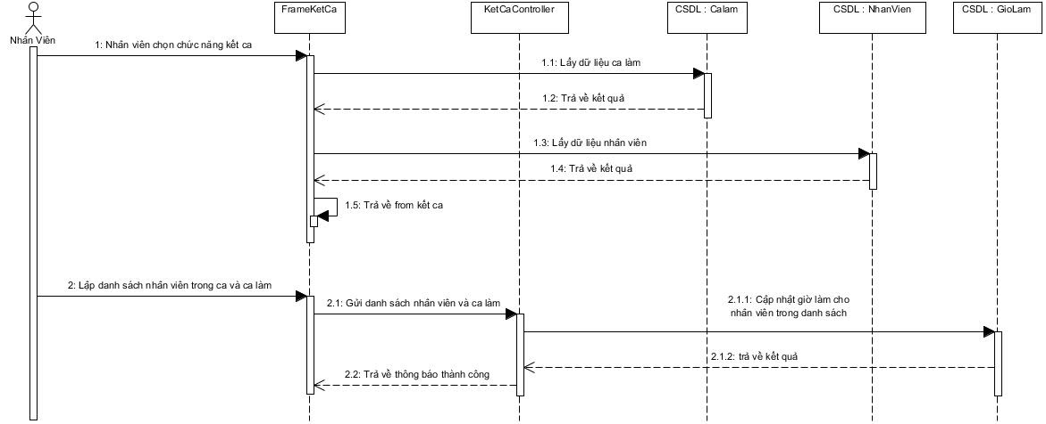

*Diagram Sequence kết ca.*

1. Activity

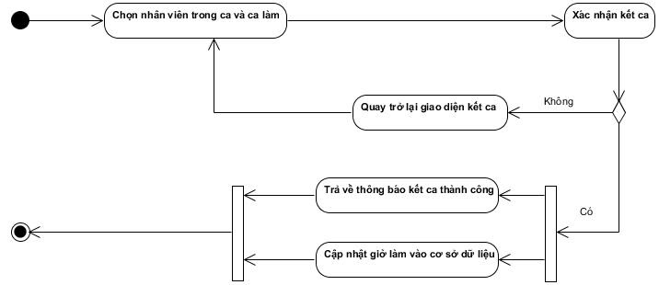

*Diagram Activity kết ca.*